RISK ASSESSMENT DETAILS | DEGREE OF RISK | RISK RATING MATRIX
Other assessments which might also be required, ✓ if needed:  - Manual Handling REF  - COSHH REF  - Personal Protective Equipment (PPE) REF  - Noise REF  - Other REF
  Faculty/School/Service | Mathematics
  Team | Sam Pegler & Onno Bokhove/Maths Fluids Laboratory
  Risk Assessment Title | Wavetanks (one glass screwed on table and one portable Perspex one)
  Risk Assessment Log Reference
  Date | 22-01-2021 and 10-05-2021
  Name of Assessors
  Manager Responsible | 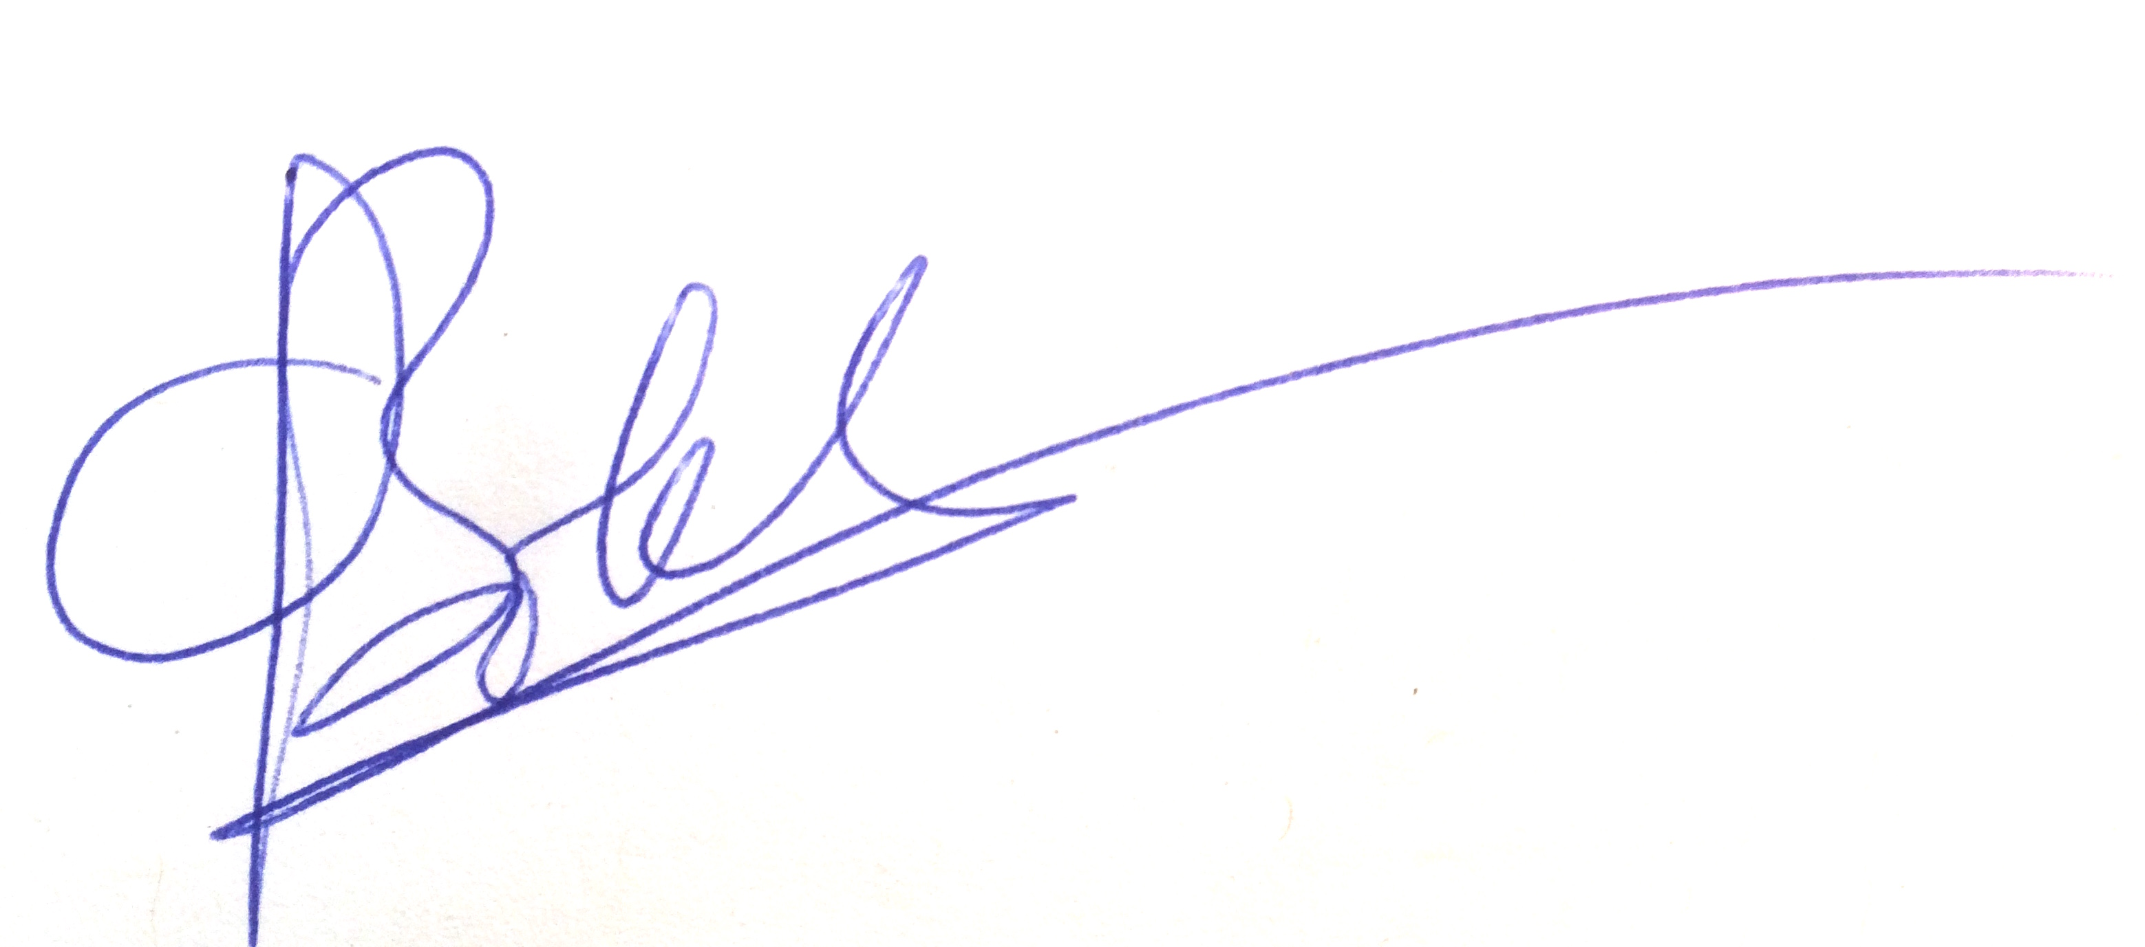
  Location | Chemistry B13
  Details of Activity
  1) Perspex wave tank (~2m length), involves an electrically powered oscillating plate of Perspex to create waves in a layer of water inside the tank.
  for link on 2) see YouTube movie: https://www.youtube.com/watch?v=3yNoy4H2Z-o
  2) A different smaller glass wave tank fixed on table.
  LIKELIHOOD (L)
  5 | Inevitable
  4 | Highly Likely
  3 | Possible
  2 | Unlikely
  1 | Remote Possibility
   |  | SEVERITY
  LIKELIHOOD |  | 1 | 2 | 3 | 4 | 5
  LIKELIHOOD | 1 | 1 | 2 | 3 | 4 | 5
  LIKELIHOOD | 2 | 2 | 4 | 6 | 8 | 10
  LIKELIHOOD | 3 | 3 | 6 | 9 | 12 | 15
  LIKELIHOOD | 4 | 4 | 8 | 12 | 16 | 20
  LIKELIHOOD | 5 | 5 | 10 | 15 | 20 | 25
 |  | PERSONS AT RISK
  SEVERITY (S)
  5 | Very High -Multiple Deaths
  4 | High - Death, serious injury, permanent disability
  3 | Moderate - RIDDOR over 7 days
  2 | Slight - First Aid treatment X
  1 | Nil - Very Minor

PERSONS AT RISK

Employees X

Students X

Clients

Contractors

Members of the public X

Work Experience students

Other Persons

  REVIEW DATES
  RISK RATING SCORE | ACTION
  1 - 4 | Broadly Acceptable - No action required
  5 - 9 | Moderate - Reduce risks if reasonably practicable
  10 -15 | High Risk - Priority Action to be undertaken
  16 -25 | Unacceptable -Action must be taken IMMEDIATELY

HAZARD AND RELATED ACTIVITIES  e.g. trip, falling objects, fire, explosion, noise, violence etc. | PERSONS  AT RISK  e.g. Employees, Customers, Contractors, Members of the public | POSSIBLE OUTCOME | RISK RATING BEFORE CONTROLS (LxS) | EXISTING CONTROLS  e.g. Guards, Safe Systems of Work, Training, Instruction, Authorised Users, Competent Persons, Personal Protective Equipment (PPE) | RISK RATING AFTER CURRENT CONTROLS (LxS) | FURTHER CONTROLS REQUIRED? | RISK RATING AFTER ADDITIONAL CONTROLS (LxS)
Electrocution | All | Death/Injury | 3x4=12 | Cables taped in place.  Socket above tank level so splashed water cannot contact (16V system); see BaseTech specs in blue coloured text  Secured so no one walks between tank and socket (or taped to ground).  PAT testing/visual inspection required | 2x4=8 | Basetech BT-305 Single Output 150W Variable Bench PSU 0-30VDC 0-5A  resides away from the wave-flap motor which is enclosed above the tank.  230V AC, 50Hz (±10%)  0 to 15V DC  0 to 3A  IP42 to Ip43 but item away from water. | RCD: Residual Current Device  is added.  A residual-current device (RCD), residual-current circuit breaker (RCCB), or ground-fault circuit interrupter (GFCI) is a device that quickly breaks an electrical circuit to prevent serious harm from an ongoing electric shock. ... RCDs are testable and resettable devices.
Falling objects (knocking over tanks) | All | Injury from slipping/falling | 3x2=6 | Tank 1) is secured on a table; nearly impossible to knock it off.  Tanks 1) and 2) are heavy when filled due to its own weight so unlikely. | 2x2=4
Tripping on cables | All | Injury from tripping | 2x2=4 | System located near the wall with socket so no cables to run across the room. | 2x2=4
Lone working (during Covid-19) | 1 | Alone during injury | 2x2=4 | Per the SOP:  Only 1 person in the lab per day, except for occasional assistance with transport.  All lab surfaces need to be disinfected using sanitary paper towels provided. The towels need to be disposed of in a special sanitary bin, disposed via general waste.  When working alone, arrange a buddy. Let the buddy know when you plan to work in the lab and for what times. Send a quick message to them at the start and end of each of your working sessions and every 2-hour interval.  In case buddy not on site and escalation required, contact site manager Ian Blakely I.J.Blakeley@leeds.ac.uk  +44(0)113 343 6472  Leave the door propped open.  Out of hours working is currently not allowed unless by special request via the HoS and H&S (normal working hours in chemistry currently allow work between 7am and 8pm)  There is a telephone  This can be used to call emergency services or security. Be aware that there is a porters’ office across the corridor that is usually occupied. | 2x1=2 | Added: have a camera open with the buddy.
Sharp edges wavemaker | All | Minor injury from cuts | 2x2=4 | First aid box available in case of any minor cuts. | 2x2=4
Waste stream cleaned | All | - | - | There is no waste stream; clean water is used and tanks are emptied directly or for Wetropolis within circa 24-36hrs, so this is covered under clean-up. | - | No
Clean-up | All | Illness and poor experiments | 2x1=2 | If the equipment is not to be used for a while, i.e. within 24-36hrs, then it should be emptied and left dry (from a legionnaire's perspective and from a growth-viscosity perspective). Wavetank should in principle always be emptied directlt after use. Is/was already normal practice. | 2x1=2 | No | Clean-up

MANAGEMENT AGREED  ADDITIONAL CONTROL MEASURES REQUIRED |  | ACTIONED BY |  |  | ACTION COMPLETE
 |  | POSITION | NAME | DATE | MANAGER SIG |  | DATE

COMMUNICATION OF RISK ASSESSMENT FINDINGS TO STAFF
REFERENCE OF FORMAL COMMUNICATION TO STAFF | METHOD | YES | DATE | COMMENTS
REFERENCE OF FORMAL COMMUNICATION TO STAFF | Copy of risk assessment issued to staff
REFERENCE OF FORMAL COMMUNICATION TO STAFF | Controls covered in team procedure issued to staff
REFERENCE OF FORMAL COMMUNICATION TO STAFF | Staff Handbook issued to staff
REFERENCE OF FORMAL COMMUNICATION TO STAFF | Other -
ADDITIONAL METHODS OF COMMUNICATION | Induction
ADDITIONAL METHODS OF COMMUNICATION | Toolbox Talk
ADDITIONAL METHODS OF COMMUNICATION | Team Meeting
ADDITIONAL METHODS OF COMMUNICATION | E-mail circulation
ADDITIONAL METHODS OF COMMUNICATION | Other -

COMMENTS AND INFORMATION

(Use this section to record any dynamic risk assessment comments and information)

Do additional controls adequately lower high risk activities to an acceptable level? | YES / NO  If NO explain in comments box above | SIGNATURE OF MANAGER  "The risks identified in this assessment are controlled so far as is reasonably practicable"
 | YES / NO  If NO explain in comments box above | Signature: | Date:

DATE OF REASSESSMENT  (Every two years minimum) | ARE THERE ANY CHANGES TO THE ACTIVITY SINCE THE LAST ASSESSMENT? | SIGNATURE OF MANAGER

LOCATION OF CURRENT SIGNED RISK ASSESSMENT

RISK ASSESSMENT LOG
Directorate: |  |  |  |  |  | Area:
Section/Team | Risk Assessment Title | Version No. | Risk Assessment Category | Code  /Location | Risk Assessor | Manager responsible for signing off risk assessment | Date assessment signed off | Review Due | Review Date | Outstanding Controls/Actions  Yes/No | Comments

